AI Assisted Coding lab 2.4
P.DEEPAK
2303A52179
Batch – 42
Question 1: Task 1: Book Class Generation Use Cursor AI to generate a Python class Book with attributes title, author and a summary method.
Prompt: Generate a python class book that contains the attributes title author and summary method
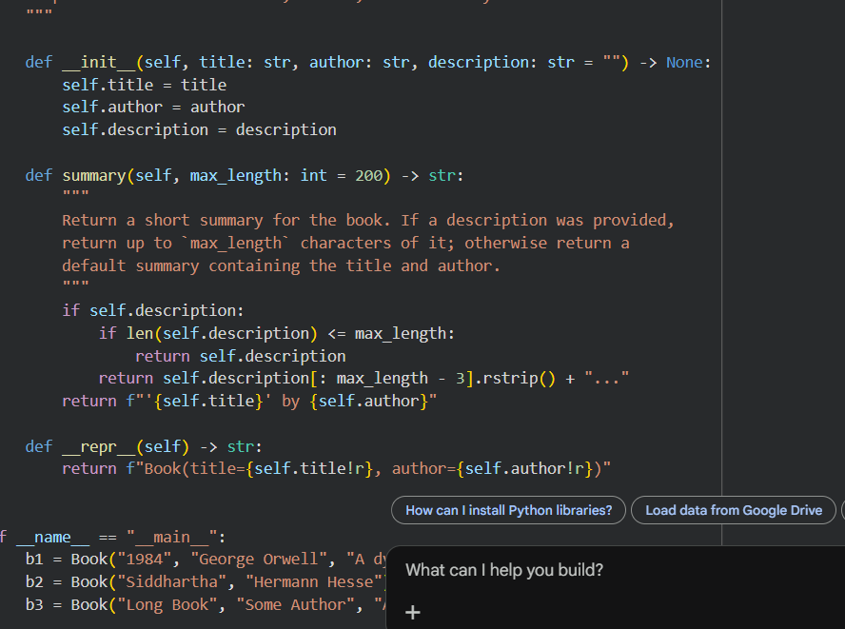
Output:

Justification: This program generates a code for library management. It correctly creates a Book class with required attributes. The constructor initializes title and author clearly. The summary method returns meaningful information. The code follows proper Python class structure. It is easy to read and understand. The class can be reused in other programs. Cursor AI generated clean and well-structured code.
Question 2: Task 2: Sorting Dictionaries with AI Use Gemini and Cursor AI to generate code that sorts a list of dictionaries by a key.
Prompt: Generate a optimized python code that sorts a list of dictionaries by a key value
Code:
Cursor ai:
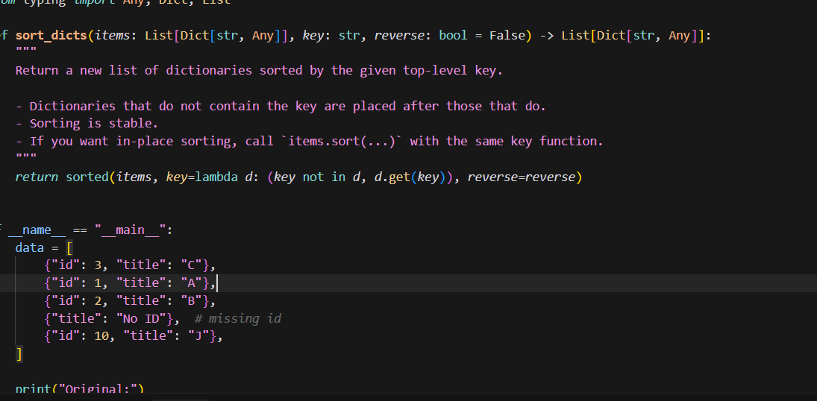
Output:
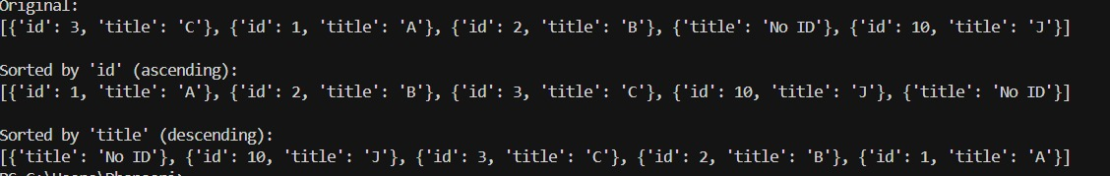
Code gemini :
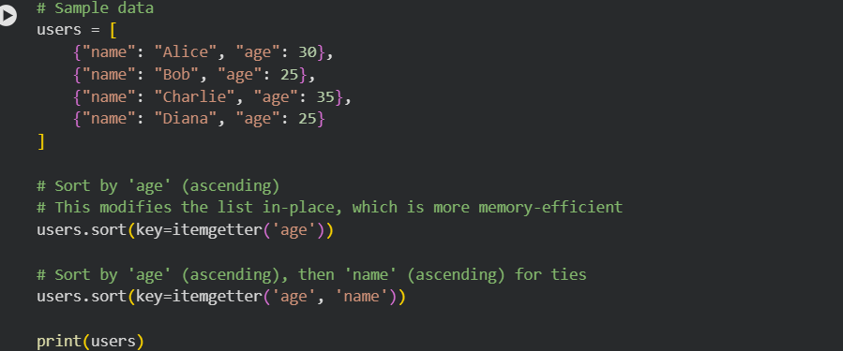
Output
Justification: The Cursor AI code uses a function, which makes the solution reusable and modular. It allows sorting by any key passed as a parameter, making it flexible. The code is short and efficient, suitable for reuse in larger programs. The Gemini code is more explanatory and beginner-friendly. Gemini also shows both ascending and descending sorting clearly.
However, Gemini’s code is less reusable since it is written directly in the main block. Cursor AI focuses on clean design, while Gemini focuses on clarity and learning. Both produce correct outputs, but Cursor AI is better for scalable applications.
Question 3:
Task 3: Calculator Using Functions Prompt: Generate an optimized Python calculator program using functions. The program should allow the user to choose operations. It should contain at least five operations addition, subtraction, multiplication, division, and exponentiation. For addition and multiplication, allow the user to input and operate on more than two numbers. For subtraction and division, restrict the operation to exactly two numbers. The code should be efficient, readable.
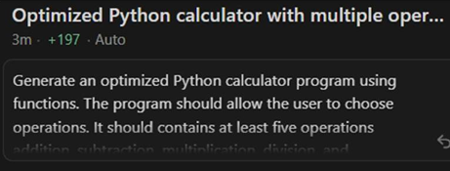
Code:
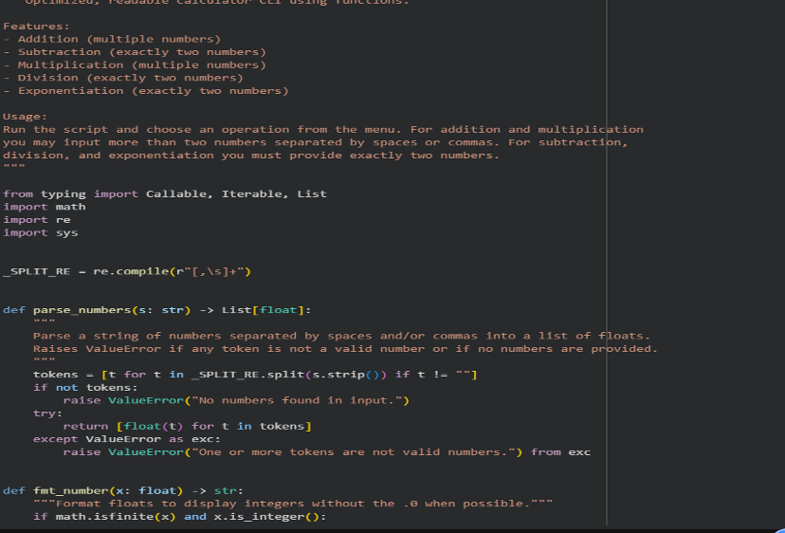
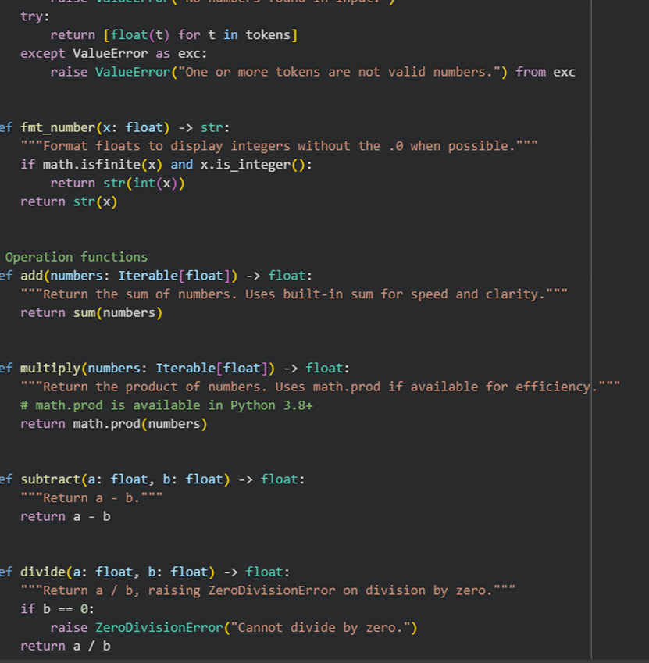
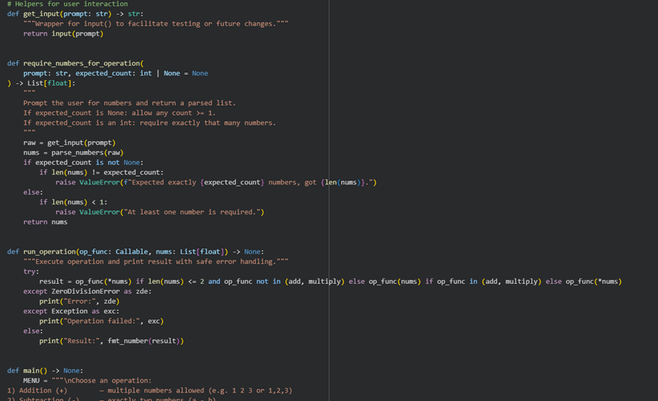
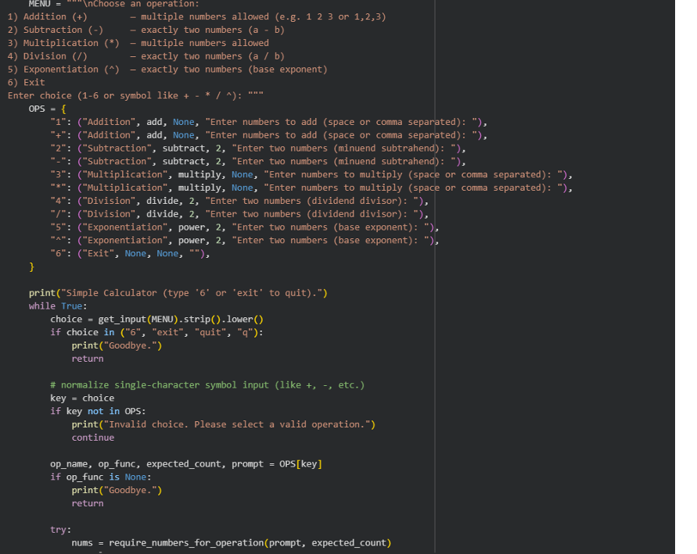
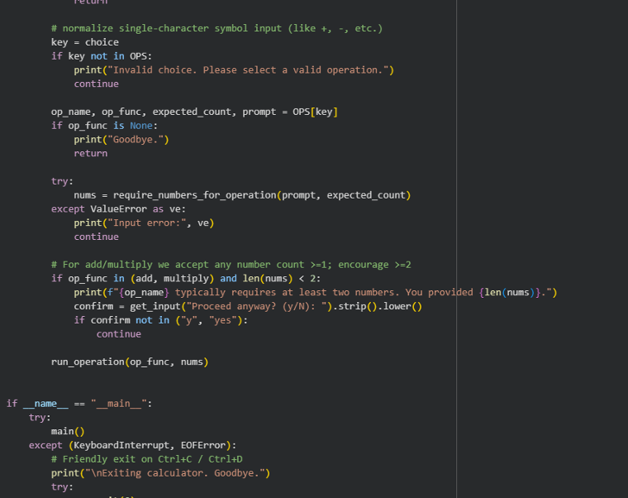
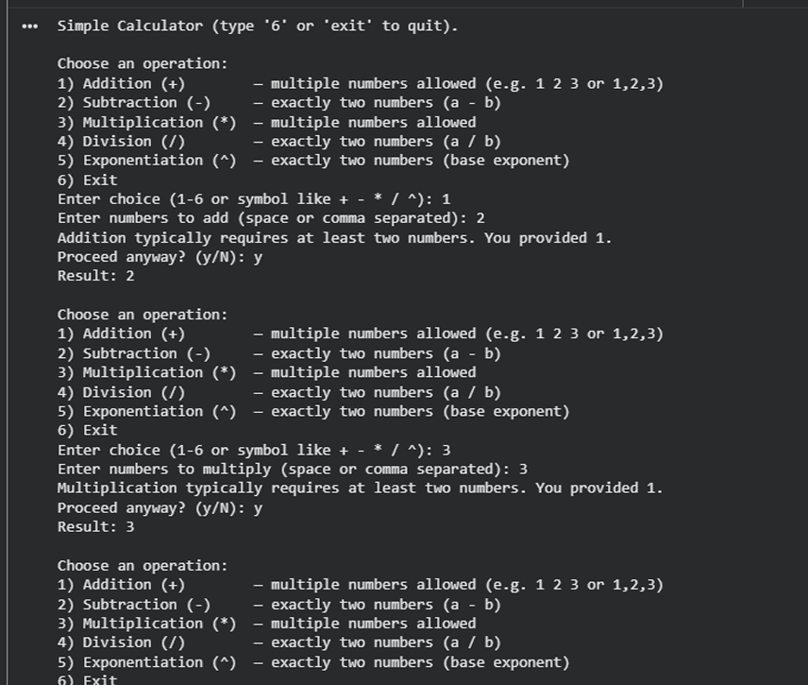
Justifications: The code is modular, with separate functions for each arithmetic operation. This approach makes the calculator easy to use and interactive. Multiple-number support is provided for addition and multiplication. Clear prompts and messages improve user experience. The loop allows repeated calculations without restarting the program. Overall, the code is readable, efficient, and easy to maintain. Question 4
Task 4: Armstrong Number Optimization Prompt: Gemini: Write a Python program to check whether a given number is an Armstrong number. The program should contain a number as input from the user. It should display whether the number is an Armstrong number or not. Cursor AI: Write a optimized Python program to check whether a given number is an Armstrong number. The program should contain a number as input from the user. It should display whether the number is an Armstrong number or not. It should be efficient and readable
Gemini ai:
Code &output:
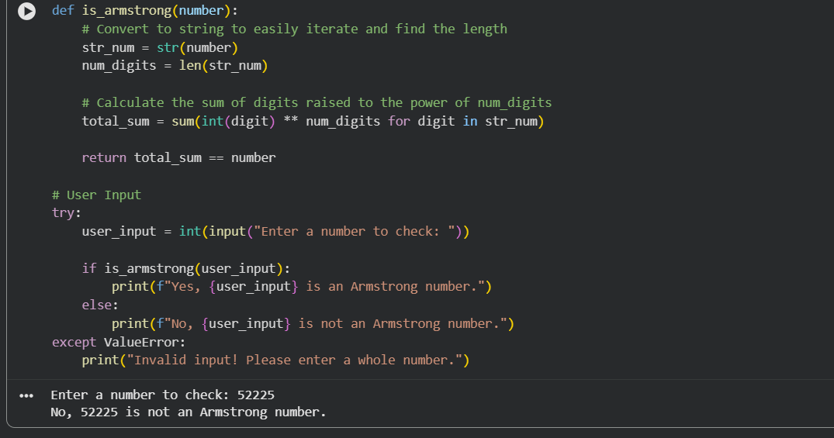
Cursor ai:
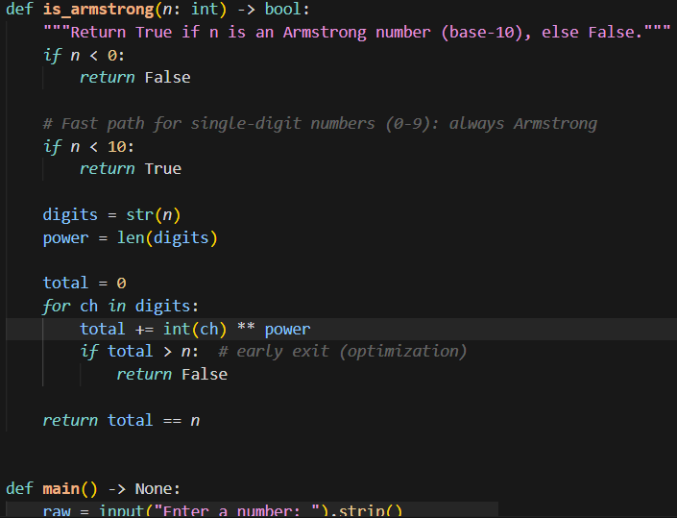
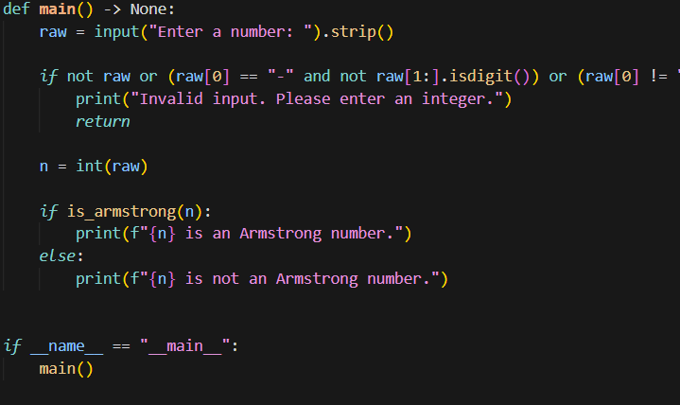
Output:
